**Create HTTP Requests to Communicate with Mobile App**

|  |  |
| --- | --- |
| **Team Id** | PNT2022TMID08806 |
| **Title** | Hazardous Area Monitoring  for Industrial Plant using IoT |

**Node red flow**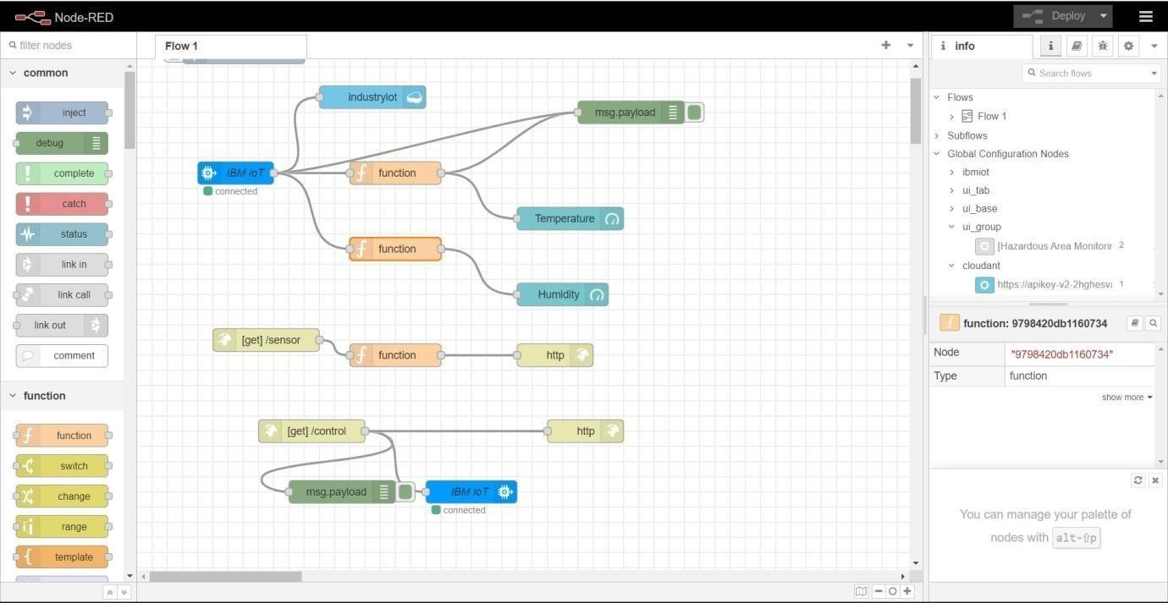

**HTTP requests**

